Commonwealth of Massachusetts
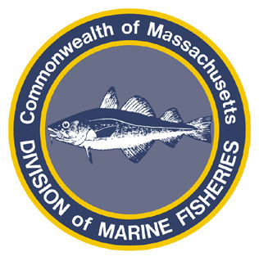Paul J. Diodati
Director

Division of Marine Fisheries
251 Causeway Street, Suite 400
Boston, Massachusetts 02114
(617)626-1520
Fax (617)626-1509
Deval Patrick
Governor

Ian A. Bowles
Secretary

Mary B. Griffin
Commissioner

March 30, 2009

Mr. David Hill, Environmental Engineer
DEP, Waterways Regulation Program
20 Riverside Drive
Lakeville, MA 02347

Re: W09-2612

Dear Mr. Hill:

The Division of Marine Fisheries (MarineFisheries) has reviewed the Waterways Regulation Application by the Town of Harwich to dredge approximately 319,400 square feet of Allen Harbor in the Town of Harwich, with respect to potential impacts to marine fisheries resources and habitat.

The proposed project lies within mapped shellfish habitat which is afforded protection under the Wetlands Protection Act (310 CMR 10.34).

The waters of Allen Harbor and the surrounding embayments have been identified as winter flounder (Pseudopleuronectes americanus) spawning habitat. Winter flounder enter the area and spawn from January through May, laying clumps of eggs directly on the substrate. These demersal eggs hatch approximately fifteen to twenty days later. The Atlantic States Marine Fisheries Commission (ASMFC) has designated winter flounder spawning habitat as “Habitat Areas of Particular Concern” (HAPC). Every effort should be taken to protect flounder spawning habitat.

MarineFisheries offers the following comments for your consideration:

- Southeastern New England winter flounder stocks are considered to be overfished. Current stock assessments place the flounder population at a 30 year low. The Atlantic States Marine Fisheries Commission’s Fishery Management Plan, Addendum 1 recommends that all states take a risk adverse management approach to protect winter flounder spawning and juvenile development. In an effort to protect winter flounder, MarineFisheries recommends a time-of-year (TOY) restriction prohibiting dredging from January 15 through May 31 of any year;
- Eelgrass (Zostera marina) beds are situated directly outside of the harbor entrance. To prevent sediment and turbidity impacts to this valuable resource area, full length, bottom weighted turbidity curtains should be required around the dredge at all times;
- Plans indicate that the top of the slope appears to be at the MLW line at some locations. The dredge side slope and the top of the slope location is not a constructed feature but an anticipated equilibrium profile based on dredge depth and sediment composition. In order to reduce the potential for intertidal impacts from dredging, the toe of slope should be adjusted away from the MLW line to account for potential instances where the ultimate equilibrium slope profile is greater than that anticipated in the project design.
- If the Town of Harwich combines the dredge project with the Oyster Creek Preservation Inc. Project, MarineFisheries recommends a time-of-year (TOY) restriction on dredging from May 1 – October 1 to protect shellfish spawning and development. Based upon information from MarineFisheries’ Shellfish Project, Oyster Creek is considered a valuable shellfish resource area with a substantial shellfish population. The applicant, Oyster Creek Preservation Inc., under supervision of the Shellfish Constable, should be required to remove all shellfish from the area prior to the dredging and replant the shellfish after dredging. This will protect the standing crop of shellfish in Oyster Creek. However, the removal of shellfish from an area is avoidance not mitigation and does not address the loss of shellfish habitat. As this project may have long lasting detrimental impacts on the Creek’s shellfish habitat, the applicant should be required to submit a mitigation plan to address the potential long term loss of habitat. The proponent should contact the Harwich Shellfish Constable and MarineFisheries’ shellfish biologists for assistance to develop a mitigation plan;
- Portions of Allen Harbor to be dredged by the Town, Allen Harbor Yacht Club, Allen Harbor Marine Services and other property owners are mapped by MarineFisheries as shellfish habitat for quahogs (Mercenaria mercenaria), soft shelled clams (Mya arenaria) and American oysters (Crassostrea virginica). The shellfish constable should coordinate with commercial and recreational shellfishermen to harvest as much of the resource as possible during the seasonally approved time of year before the start of the dredging.

Any questions about this review may be directed to Frank Germano in our New Bedford office at (508) 910-6344.

Sincerely,
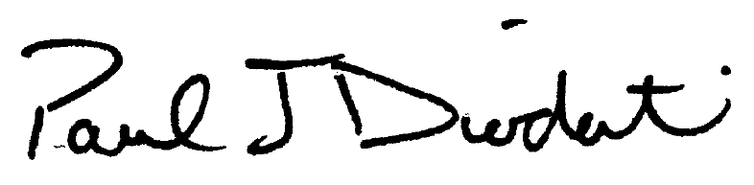
Paul J. Diodati
Director

cc: Harwich Conservation Commission
Thomas Leach, Harwich Shellfish Constable
Amy Lipkind, Coastal Engineering Co., Inc.
Eileen Feeney, DMF
Terry O’Neil, DMF
Heather Marshall, DMF
Ken Chin, DEP

